Post Offices Screen
  - Purpose
    - This screen manages the information of different Post Offices.
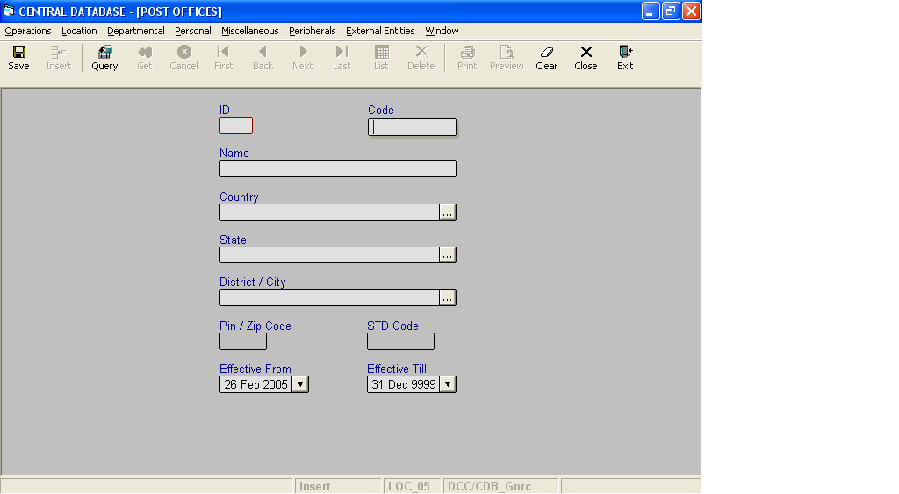

Layout as seen on opening of the Screen
  - Events associated
None
  - Modes
    - It will start in Insert mode.
    - It supports Insert, Query, Retrieve, Browse and List modes.
  - Field specifications
 | Type | Length | Optional | Insert Mode | Query Mode | BrowseMode
ID | post_office_id | 4 | N | N.A. | Allow | Display
Code | char | 10 | N | Allow | Allow | Allow
Name | varchar | 35 | N | Allow | Allow | Allow
Country | Key |  | N | Allow | Allow | Allow
State | Key |  | N | Allow | Allow | Allow
District/City | Key |  | N | Allow | Allow | Allow
Pin/Zip Code | pin_or_zip_code | 6 | Y | Allow | Allow | Allow
STD Code | Varchar | 10 | Y | Allow | Allow | Allow
Effective From | datetime | 8 | N | Allow | Allow | Allow
Effective Till | datetime | 8 | N | Allow | Allow | Allow
  - Fields
    - ID
      - This is the Post Office ID, which uniquely identifies all the Post Offices.
      - This field will be automatically generated by the system.
      - The user will be informed of the generated ID as part of the message which will be shown on successful saving of information in Insert Mode.
    - Code
      - This is the code of the Post Office.
      - It is user defined. It can be changed in Browse Mode.
    - Name
      - This is the name of the Post Office.
      - The name can be changed in Browse Mode.
    - Country
      - This field specifies the Country to which the Post Office belongs.
v. State
a) This field specifies the State to which the Post Office belongs.
vi. District/City
a) This field specifies the District/City to which the Post Office belongs.

- Pin/Zip Code
  - This is the Pin/Zip code of the Post Office.
  - The Pin/Zip code can be changed in Browse mode.
  - Pin code should contain only digits. It has been kept as varchar so that like searches can be made.
- STD Code
a) This is the STD code of the Post Office.
b) The STD code can be changed in Browse mode.
c) STD code should contain only digits. It has been kept as varchar so that like searches can be made.
viii. Effective From
a) This is the date since which a Post Office is effective.
      - By default, the system will display the current date in Insert Mode.
      - Normally, it should not be a future date. This is the recommendation. System will display a warning, if future date is specified.
      - It cannot be later than the date specified in Effective Till.
ix. Effective Till
a) This is the date till which a Post Office is effective.
b) By default, the system will display 31-Dec-9999 in Insert Mode.
c) Normally, it should not be a past date.
d) It cannot be earlier than the date specified in Effective From.
  - Lookup or Help
Field | Items of Information as will be shown | Remarks
Country | Name, Code | Only active Countries will be shown.
State | Name, Code | Only active States will be shown.
District/City | Name, Code | Only active Districts/Cities will be shown.

  - Action Buttons
None
  - Users / User Roles
CDB_Gnrc user is permitted to insert, update, delete and select Post Office.
  - Other Considerations
- A post office is uniquely defined by the combination of code of the post office, country, state and district.
- A post office is uniquely defined by the combination of name of the post office, country, state and district.

